BHT Sussex
BHT Sussex is a charity and a registered housing association working in Brighton and Hove, Eastbourne, Hastings and other parts of Sussex.

BHT Sussex’s Mission is to combat homelessness, create opportunities, and promote change and aims to achieve this Mission through a network of interlinked projects. By providing direct, practical services combined with a commitment to challenge the causes of poverty and inequality, we hope to achieve a supportive structure which people can use in a variety of ways to improve the quality of their lives.

Project / Department Details
Shore House is an innovative service which provides accommodation and intensive support to 20 people with mental health diagnoses and complex needs, including those with a dual diagnosis, and people experiencing the effects of complex trauma.
The service works creatively and proactively with people to build their skills and confidence, enabling them to move into more independent accommodation within an 18-month timeframe.
The service applies Psychologically Informed, Trauma Informed and Recovery Focussed models that put client experience at the heart of service delivery. We care about how someone makes progress and what it means to them, not just about the outcomes.
The service works collaboratively with primary and secondary health services, statutory and third sector services. Multi-agency support and risk reviews are led by the service and alongside our clients to plan and support individual journeys of recovery.
Person-centred 1:1 and group work support is provided for a range of areas, including mental and physical health, medication management & treatment plans, personal safety, personal and social development, and work and learning.

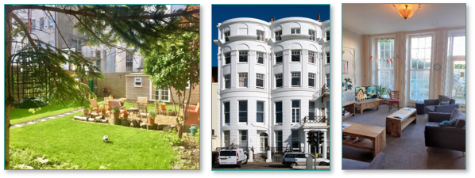

Job summary
As a Support Worker you will deliver empowering, motivating, and personalised support to clients to enhance their emotional, physical, and financial well-being. For example: improving community engagement and social confidence, providing practical support with cooking and self-medication, and assistance with budgeting and tenancy management.

Key responsibilities include:
- Provide intensive support to prevent rent arrears, self-neglect, anti-social behaviour, and tenancy breakdown.
- Be a named worker for an identified caseload of residents and take responsibility for liaising closely with relevant care teams and/or agencies, including Lead Practitioners and GPs.
- Use the Outcomes Star and risk assessments to assess needs and goals and develop safety/risk and support plans.
- Work alongside Sussex Partnership NHS Foundation Trust and the substance misuse service to provide recovery-focused structured support.
- Safely administer prescribed medication to clients, and liaise with GPs, psychiatrists and pharmacies as appropriate.

Salary
The salary is paid monthly in arrears and will be £25,948 plus £1,469 Anti-Social Hours Enhancement pro rata An employer pension contribution 5.5% is paid. The level of this contribution is reviewed annually.

Hours of Work
6-week rolling rota, averaging 37 hours per week. Early & Late shifts between the hours of 8am and 10.30pm. Working alternate weekends.

Annual holidays
The annual leave entitlement will be 27 working days, rising 1 day for each year of service to a maximum of 32 days pro rata. All public bank holidays are granted.

Closing Date: Friday 13th October 2023

Interview Date: TBC

We regret that we are unable to reply to every job applicant. However, if you are called for interview, you will be notified within seven days of the closing date.
An Enhanced DBS Check (Disclosure and Barring Service) is required on all successful applicants as a condition of employment for this post.
BHT operates an Equal Opportunities Polic

